G-V1018B Double Column Machining Center
Technology Agreement

Party A（Buyer）： | Represent:  Date:
Party B（Seller）：Shenzhen Create Century Machinery Co., Ltd. | Represent:  Date:

1、Equipment technical description, parameters and configuration
1、Equipment technical description
G-V1018B double column machining center is a large and medium-sized machine tool. The workpiece can automatically and continuously complete milling, drilling, boring, expanding, reaming, countersinking, tapping and other processes after one clamping. The machine tool is suitable for large Processing of various types of small and medium-sized batches of complex parts such as medium-sized boxes, plates, disks, valves, and shells.
- The whole machine structure is a double column structure, with integrated columns and beams designed to improve the overall rigidity of the columns. The basic large parts are made of high-quality resin sand molding and high-strength cast iron materials to ensure high rigidity and stable accuracy of the machine tool. The main castings have undergone finite element analysis, and the ribs are reasonably arranged to fully meet the needs of high-torque cutting of machine tools.
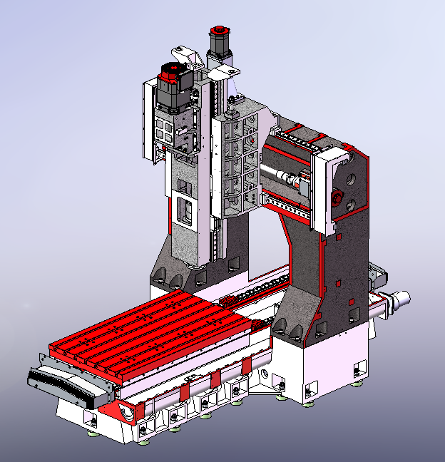
- The spindle uses a BT50-6000rpm spindle unit, and a self-made reduction gearbox is added to meet the needs of heavy cutting. The cutting efficiency is high, and the reduction gearbox is equipped with an oil cooling function to reduce thermal deformation of the spindle.
- The front end of the spindle adopts a labyrinth design, and the spindle has an air curtain protection function to prevent cutting fluid from entering the spindle bearing.
- The spindle has central air blowing function and is equipped with an automatic circulating water cooling device to stabilize temperature and prevent thermal deformation of the spindle and maintain high machining accuracy.
- The main spindle box movement (Z-axis) is equipped with a nitrogen balance device. Even when moving at high speed, the counterweight will not shake; the precise ratio of the counterweight to the main spindle box weight can obtain the best processing characteristics, and the Z-axis drive motor has Good load characteristics.
- The three-axis feed adopts a direct connection drive method between the motor and the high-precision ball screw. The large-diameter ball screw is pre-stretched and installed to further improve the transmission rigidity and positioning accuracy.
- The Y-axis guideways uses MSR55LS roller guideways to carry the load. The X/Z-axis guideways uses MSR45LS roller guideways It has high rigidity, low friction, low noise, strong shock resistance, and can carry greater cutting forces.
- The guide-ways and ball screws of the machine tool adopt a timed and quantitative lubrication system, which can adjust the oil supply cycle and amount of each lubrication point, and realize fully automatic centralized lubrication through electrical system control.
- The chip removal of the machine tool adopts double screw conveyor, which is automatic, user-friendly and high-efficiency. It is also equipped with a front chain plate chip conveyor, which greatly reduces manual cleaning time.
- The machine tool water tank adopts a multi-layer filtration system structure to provide good cutting fluid for workpiece processing.
- The machine tool is equipped with a high-performance FANUC 0i-MF PULS (5) CNC system, which ensures the stability of machine tool control and also ensures the CNC processing functions and auxiliary functions required by users.
- working conditions
- Power supply: three-phase AC 380V±10%; 50Hz±1Hz; the machine tool should have reliable grounding: the grounding wire is a copper wire ≥16mm²; the grounding resistance is <4Ω.
- In order to keep the static accuracy of the machine tool within the guaranteed value range, the machine tool should be installed in an area not affected by air flow. It is necessary to keep the surrounding temperature between 17℃~25℃, the humidity between 40% and 75%, and The ambient temperature change within 24 hours should be within ±2°C, and the ambient temperature change from the ground to about 5 meters high should be maintained within 2°C.
- If the requirements for the parts being processed are not high, the ambient temperature range can be relaxed to 10°C ~ 40°C.
- Keep away from light sources, vibration sources and heat sources, and away from high-frequency generators, discharge motors, welding machines, etc. to avoid electrical interference that may cause the machine tool NC system to malfunction.
- If the voltage in the area where it is used is unstable, the machine tool should be equipped with a regulated power supply to ensure the normal operation of the machine tool.
- In order to ensure the normal operation of the equipment, if the compressed air source does not meet the cleanliness requirements, an air source purification device (dehumidification, oil removal, filtration) should be added before the air intake of the machine tool.
- In order to maintain the accuracy and stability of the machine tool, the foundation must be made strictly in accordance with the requirements of the foundation diagram provided by the company.

2. Equipment parameters and configuration
2.1. Basic parameters
Item |  |  | Unit | Parameters | Remark
Processing range | X axis |  | mm | 1800
Processing range | Y axis |  | mm | 1100（+100 tool changing stroke）
Processing range | Z axis |  | mm | 800
Processing range | Door width |  | mm | 1160
Processing range | Distance from spindle end face to worktable |  | mm | 100～900
Processing range | Distance from spindle center to column guide surface |  | mm | 474
Worktable | Size |  | mm | 1800*1000
Worktable | Max load  Workbench load-bearing |  | kg | 3000
Worktable | T-shaped slot (number of slots-slot width*spacing) |  | mm | 7-22*140
Spindle | Motor power (rated/short time) |  | kW | 15/18.5
Spindle | Spindle torque (rated/short time) |  | N▪m | 573/945 | Gear drive
Spindle | Spindle speed |  | r/min | 50～6000
Spindle | Spindle diameter |  | mm | Φ210
Spindle | Spindle taper |  |  | BT50
Spindle | Pull stud |  |  | P50T-I（MAS403）
Guideways | X-axis |  | mm | 2-45 Roller
Guideways | Y axis |  | mm | 2-55 Roller
Guideways | Z axis |  | mm | 2-45 Roller
Drive | Lead screw X/Y/Z |  | mm | 50*12/50*12/50*12
Drive | Servo motor power X/Y/Z |  | kW | 3/3/3
Speed | Cutting feed speed range |  | mm/min | 1-10000
Speed | X, Y, Z axis rapid movement speed |  | m/min | 16/16/12
Precision | Positioning accuracy（X/Y/Z） |  | mm | 0.015/0.012/0.012
Precision | Repeat positioning accuracy（X/Y/Z） |  | mm | 0.008/0.008/0.008
Tool magazine (optional) | Tool magazine capacity |  | T | 24
Tool magazine (optional) | Maximum tool weight |  | kg | 18
Tool magazine (optional) | Tool length |  | mm | 350
Tool magazine (optional) | Maximum diameter (full tool/adjacent empty tool) |  | mm | Φ110/Φ200
Other | Z-axis counterweight |  |  | Nitrogen balance
Other | CNC system |  |  | FANUC 0i-MF PULS (5)/β motor
Other | Air | Flow | L/min | 280（ANR）
Other | Air | Air pressure | MPa | 0.5∼0.8
Other | Total power capacity |  | KVA | 40
Other | Cooling box volume |  | L | 400
Other | Machine tool appearance dimensions |  | mm | 4500*4250*3900 | Corresponds to X*Y*Z axis

2.2. Equipment standard configuration
No. | Item | Quantity | Remark
 | FANUC 0i-MF PULS (5)/β motor CNC system | 1
 | Operation panel | 1
 | Pneumatic system | 1
 | Air gun | 1
 | Automatic lubrication system | 1
 | Spindle cooling system (water cooling) | 1
 | Gearbox cooling system (oil cooling) | 1
 | Workpiece cooling system | 1
 | Spiral chip conveyor | 2
 | Full protection | 1 | No cap
 | Three-color signal light | 1
 | Lighting device | 1
 | Basic installation kit | 1
 | Operating foot pedal | 1
 | Technical documents | 1
 | Chain plate chip conveyor | 1
 | Hydraulic pressure station | 1

2.3、Customer chooses configuration
No. | Item | Whether to Choose | Remark
1 | Column heightening 200 (heightening pad) | □ | The distance between the spindle end face and the work surface is 300-1100 mm
2 | BT50-24T disc type tool magazine | □ | TaiKan
3 | 2MPa center through coolant | □
4 | 3MPa center through coolant | □
5 | Coolant gun | □
6 | BT50 manual right-angle milling head (2000 r/min) manual head change/ release/ rotation | □ | Cannot process inclined surfaces
7 | grating ruler | □ | Fagor
8 | grating ruler | □ | Heidenhain
Note: If you select this configuration, please mark √ in the corresponding item box. This table only lists the main selected configurations. For other selected configuration items, please consult the manufacturer and fill in the blanks.

3.Recommended oil and grease
Lubrication part | Name | Capacity | Trademark | Manufacturer recommendation | Remark
hydraulic station | Hydraulic oil | 40L | No. 46 | Shell Tellus 46  Or Great Wall HF-2 46 | Replace it after 3 months of initial use; replace it every 6 months thereafter (optional)
Gearbox oil cooler | Hydraulic oil | 40L | No. 32 | Great Wall: L-HM 32;  Shell: TELLUS S2 M32 | Replace it after 3 months of initial use; replace it every 6 months thereafter
Spindle water cooling machine | Antifreeze coolant | 15L |  | BASF (BASF): Gulishun G48;  Mobil: -45℃ antifreeze coolant | Replace every 3 months
Lubrication pump | rail oil | 4L | 32#(winter)  68# (summer) | Shell Tonna T32 (<10 degrees)  T68 (>10 degrees)  or the great wall  HG32 (<10 degrees)  HG68 (>10 degrees) | Refill when the oil level is below the minimum level line

5、Others
- Matters not covered in this agreement shall be resolved through negotiation between the two parties.
- This agreement is an attachment to the contract and will take effect simultaneously with the contract after being signed by Party A and Party B.
- This agreement is made in duplicate, with Party A and Party B each holding one copy

